**Java**

Intro to Classes Quiz Review_____________________________________________________________

**1)** What is a class? (Yeah, it's not a specific question, but give your best answer)

Template for creating an object

Made up of instance variables - properties (length, name, color)

Methods - mutators, accessors

Constructors

**2)** What is a constructor?

Initializes the instance variables in a class

Called when a new instance of a class is created

Only called once for each object

**3)** How do you know which method is the constructor?

No return type

same name as the class

**4)** Write an example of a method that uses a parameter in your Circle class.

public int setX(int newX)

**5)** Write an example of how to use that method

Circle myCircle = new Circle(100, 150, 50);

myCircle.setX(87);

**Using this line of code for questions 6 - 9:**

Circle myCircle = new Circle(100, 150, 50);

**6)** Assuming you are using the Circle class you made, describe the Circle that is being created. How do you know what each of the values in the parenthesis does?

public Circle(int x, int y, int radius){

this.x = x;

this.y = y;

this.radius = radius;

}

Center is (100, 150)

radius is 50

Order the parameters are passed

**7)** What happens to the value 100?

the parameter x gets a copy of the value 100

this.x (the instance variable x) gets the value from the parameter x (100)

the instance variable x gets the value 100

**8)** What does the command new do?

new is called the instantiation operator

calls the constructor

creates an object based on a class

**9)** How do you know which constructor you are using?

based on the parameters (all have the same name)

**10)** How many constructors can a class have? Explain.

as many as it wants as long as the parameters are different

**11)** What is the difference between a class and an object?

a class is the definition of an object

a class is a "blueprint" for an object

String b = "Madhav"; same (mostly) as String b = new String("Madhav");

**12)** Can one Circle access another Circle's instance variables? If yes, give an example.

yes. For example:

public boolean overlaps(Circle other){

int xDiff = this.x - other.x;

this works becuase it is in the Circle class, so we can use private variables that were defined in the Circle class.

**13)** Why are instance variables usually private?

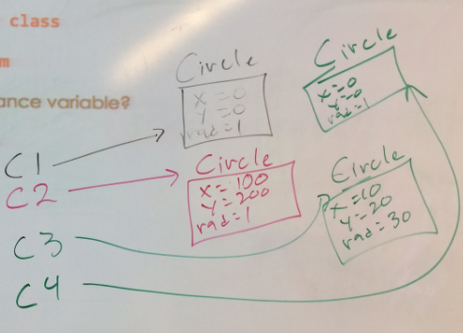

"Client" - Whoever/whatever is using the class

so the client cannot directly change them

**14)** Why is an instance variable called an instance variable?

They exisit in every instance of a class

For Example:

Circle c1 = new Circle();

Circle c2 = new Circle(100, 200);

Circle c3 = new Circle(10, 20, 30);

Circle c4 = new Circle();

if you wrote: c4 = c1;

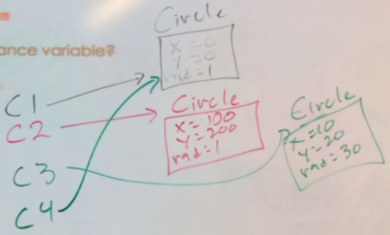

**15)** If you were making a Dog class, what instance variables would you make?

int age

String name

double height

String breed

String eyeColor

information that makes each dog unique

**16)**What is an overloaded method? Give an example.

Same name - Different parameters

System.out.print(int)

System.out.print(boolean)

System.out.print(char)

System.out.print(String)

Circle()

Circle(int, int)

Circle(int, int, int)